The Czech Republic is the unhealthiest country in the world
捷克共和國是全世界最不健康的國家

The Czech Republic is the least healthy country in the world, according to new research conducted by Clinic Compare.

Researchers analyzed World Health Organization data on alcohol consumption, tobacco consumption and the prevalence of obesity in 179 countries. According to the list, the Czechs love their booze and are the 5th biggest drinkers in the world, consuming 13.7 liters of alcohol each per year – that’s 550 shots, or 1.5 shots a day. The country also had the 11th highest tobacco consumption.
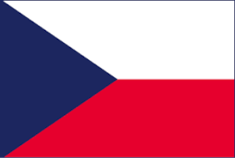
The research found Eastern Europe is the least healthy region in the world, occupying nine out of the top 10 spots. Russia is the second most unhealthy country, followed by Slovenia, Belarus, Slovakia, Hungary, Croatia, Poland, Luxembourg and Lithuania.
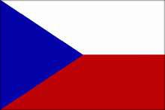

The healthiest country is Afghanistan, boasting the second lowest rate of obesity in the world. Just 2.7 per cent of the population had a BMI over 30. Plus, residents only smoked 83 cigarettes a year and drank the least alcohol.

【Word Bank】
booze：名詞，酒，含酒飲料。
shot：名詞，量酒單位（小烈酒杯）。
boast：動詞，擁有（值得自豪之物）。

取自自由時報
http://iservice.ltn.com.tw/Service/english/english.php?engno=1167152&day=2018-01-09

