Author Murakami：Joy of writing is to start not knowing end

作家村上春樹：寫作的樂趣在於初下筆時不知道結局

Best-selling Japanese author Haruki Murakami says he enjoys writing novels because he doesn’t know how they’ll end up.
Murakami, hosting a special radio show on Sunday, said he starts writing without deciding how the story should end. Ideas pop up as he writes and he goes with the flow while the stories take shape.
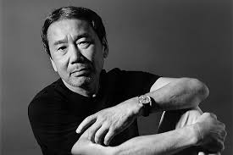
"It’s no fun writing a story if I already know how it’s going to end," Murakami said. "Because the very person who is writing doesn’t know what happens, I think readers would also share the anticipation and enjoy the thrill while reading."

During Sunday’s show, Murakami played a selection of cover versions from jazz and pop. He opened the show paying tribute to Aretha Franklin, playing her version of Frank Sinatra’s "My Way," which he only played partially in his earlier show, a week before she died.
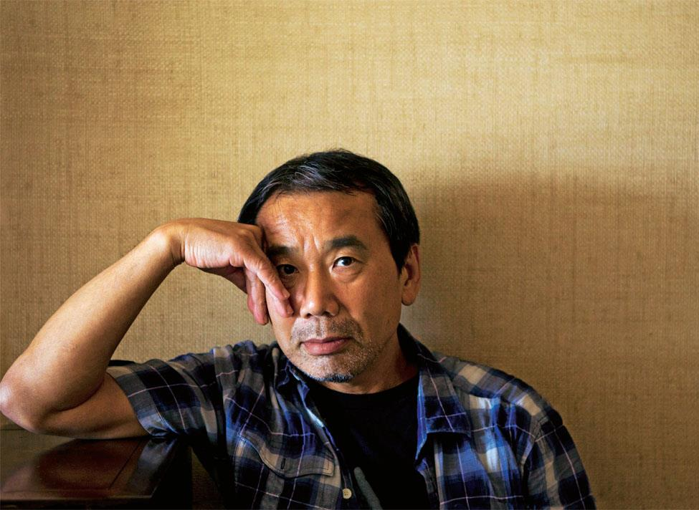

《Word Bank》
go with the flow：隨波逐流，順勢而為
take shape：成形
pay tribute：讚賞，致敬

文章網址：http://iservice.ltn.com.tw/Service/english/english.php?engno=1267608&day=2019-02-15

