Korea to continue to go nuclear-free despite Taiwan’s pro-nuclear move

即使台灣做出擁核之舉 南韓將繼續朝向非核
"Taiwanese seemed to decide to abandon its anti-nuclear policy in the wake of a massive blackout in August last year. Although our policy direction is somewhat similar to Taiwan, there are also differences," a senior official of the Ministry of Trade, Industry and Energy, who asked for anonymity, told reporters Monday.
"Although we will refer to the case of Taiwan, we will still push for our energy shift policies by strengthening communication with the public," he said. Taiwan － alongside Germany － is one of the countries that the Moon Jae-in administration benchmarked for the nation’s nuclear-free policies.
The MOTIE said it does not seem appropriate to apply the case of Taiwan directly to Korea. Korea has enough nuclear power plants to supply power in the long term, therefore it has more room for a stable phase-out, the senior official said. 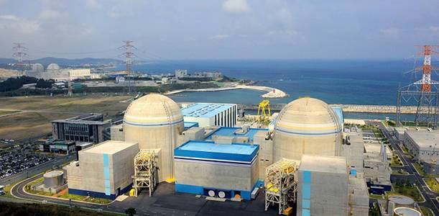

《新聞辭典》
benchmark：動詞，以（用）…為標準來衡量。
refer to：片語，參考、提及、談到。
phase-out：名詞片語，逐步淘汰、分階段停用某物。

文章網址：http://iservice.ltn.com.tw/Service/english/english.php?engno=1251094&day=2018-12-02圖片網址：http://www.koreaherald.com/view.php?ud=20181126000723

