World’s first no-kill eggs go on sale in Berlin
全球首批非殺戮雞蛋在柏林上市

The world’s first ever no-kill eggs are now on sale in Berlin after German scientists found an easy way to determine a chick’s gender before it hatches, in a breakthrough that could put an end to the annual live shredding of billions of male chicks worldwide.
The patented "Seleggt" process can determine the sex of a chick just nine days after an egg has been fertilised. Male eggs are processed into animal feed, leaving only female chicks to hatch at the end of a 21-day incubation period.
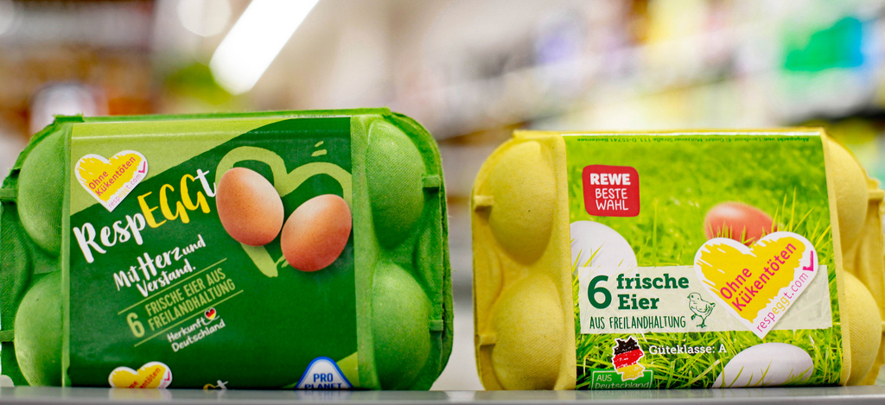
"If you can determine the sex of a hatching egg, you can entirely dispense with the culling of live male chicks," said Seleggt managing director Dr. Ludger Breloh, who spearheaded the four-year programme by German supermarket Rewe Group.
An estimated 4-6 billion male chicks are slaughtered globally every year because they serve no economic purpose. Some are suffocated, others are fed alive into grinding or shredding machines to be processed into reptile food.

【Work Bank】
dispense with：動詞片語，免除、摒棄。
spearhead：動詞，帶頭。
feed into：動詞，流入、把…放進（機器）。

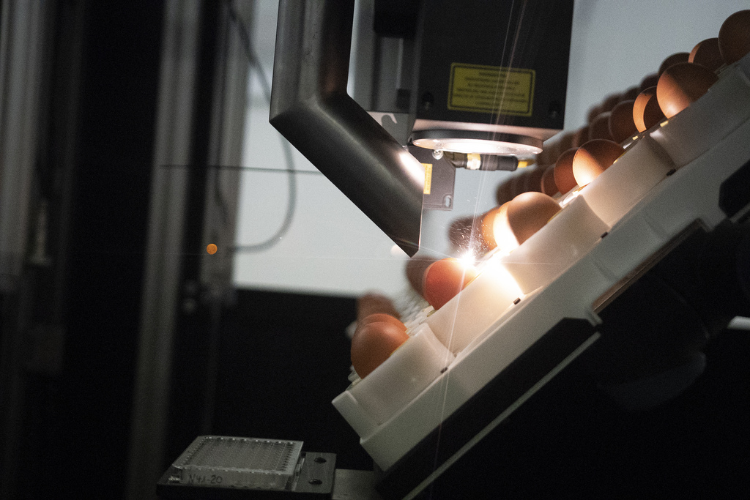

取自自由時報http://news.ltn.com.tw/news/world/paper/1256816

