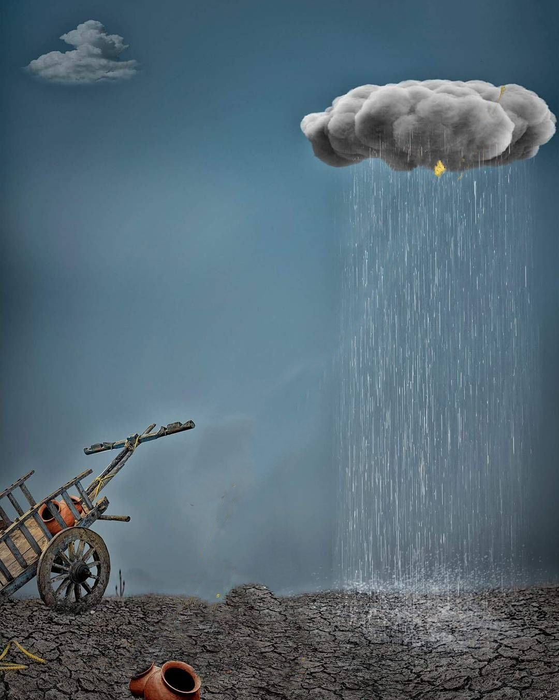
English pub scraps snail race as cold makes competitors sluggish

天氣太冷動作更慢 英國酒吧蝸牛賽跑不辦了

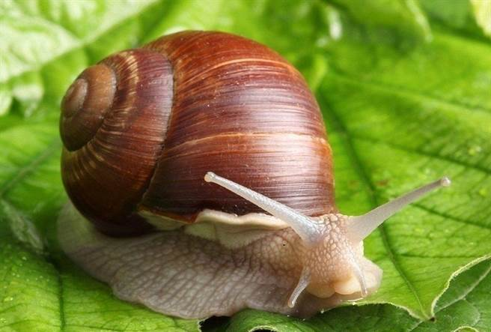
An English pub has canceled a charity snail race scheduled to take place on Saturday after unseasonably icy weather made potential competitors too slow to compete.

"The cold snap has led to a medical problem with our racing snails - it’s called hibernation," the Dartmoor Union Inn in southwest England said on its Facebook page.

Temperatures across much of Europe are below normal for the time of year, and British weather forecasters have warned of bitterly cold winds and snow that could disrupt transport and cut off rural communities over the coming week.

England’s public health authority said on Friday the prolonged cold weather posed a danger to elderly people and young children if they could not heat their homes.

The Dartmoor Union Inn said it planned to reschedule what it had billed as "The 1st International Snail Grand National", in aid of a local air ambulance service, once the weather warms up.

《World Bank》

crap：名詞，指廢料、殘餘物、小片、吵架；
動詞，指廢棄、報廢、打架；
形容詞，指廢棄的、零星的、剩餘的。

sluggish：形容詞，指行動遲緩的、反應慢的、懶散的、無精打采的。

snap：動詞，指猛然咬住、喝斥、折斷、快速傳棒球、拍快照、啪啪作響；
名詞，指折斷、突然撕咬、天氣的驟變、輕鬆的工作；
形容詞，指容易的、啪噠一聲扣下的、倉促的。

取自《自由時報》http://iservice.ltn.com.tw/Service/english/english.php?engno=1180696&day=2018-03-03

