Leaving Facebook makes people happier but less informed
離開臉書讓人更開心，但消息較不靈通

A new study has found that leaving Facebook may be good for your emotional wellbeing, but you could be less informed about current events.
A new report from researchers at New York University and Stanford University looked at what happened to people who deactivated their accounts. To track social media’s effects, the researchers recruited 2,844 Facebook users and paid them $102 to turn-off their accounts for four weeks.
The study found that temporarily quitting Facebook led to increased subjective wellbeing, less political drama and attention span agitation, and increased time spent with friends and family. On the other hand, it also led to a decrease in awareness of current events.
Psychologists have argued for years that the use of Facebook and other social media is linked to mental distress, especially in adolescents. Others have likened habitual Facebook use to a mental disorder.

【Work Bank】
deactivate：動詞，關閉、使無效、使不活動。
agitation：名詞，焦慮、躁動、緊張不安。
distress：名詞，苦惱、苦難、痛苦。

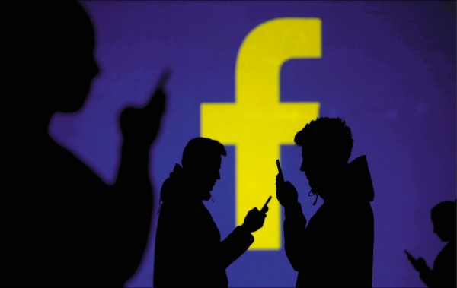

取自自由時報
http://iservice.ltn.com.tw/Service/english/english.php?engno=1266857&day=2019-02-12

