China may slow pace of tourism cooperation with N. Korea after US protest
美國抗議後，中國可能放慢與北韓的觀光業合作步調

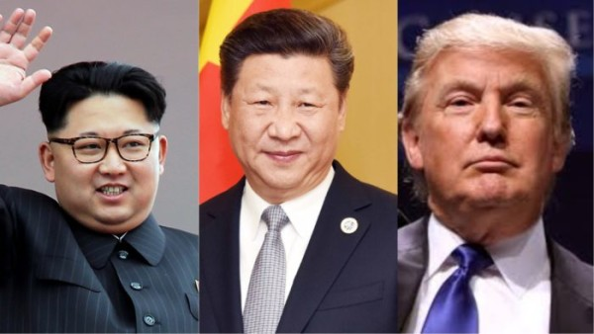
China appears to be slowing the pace of its tourism sector cooperation with North Korea, apparently in the face of complaints from the United States, industry sources said Monday.

The North’s flag carrier Air Koryo was to launch a charter flight service between Pyongyang and Chengdu in China on June 28 but canceled the plan on the same day, the sources said, adding that any rescheduling plan has yet to be announced. The sudden flight cancellation has embarrassed Chinese tour agencies, which had sold group tour packages to Chinese tourists wanting to visit Pyongyang.
After Washington reportedly warned Beijing not to loosen anti-North sanctions before its complete denuclearization, the Chinese authorities appear to be controlling the pace of economic cooperation with the North, the sources said.

【Word Bank】
flag carrier：指國家航空公司，或譯為載旗航空公司，大多會在飛機機身漆上該國國旗或國家標誌。
reschedule：動詞，重新安（編）排（時間）。
loosen：動詞，放寬（鬆）、鬆綁、解開。

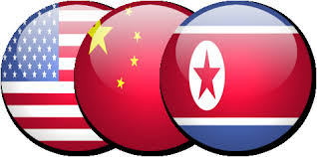

取自《自由時報》
http://iservice.ltn.com.tw/Service/english/english.php?engno=1214975&day=2018-07-08

