52 Polar Bears ’Invade’ a Russian Town to Eat Garbage

52隻北極熊「入侵」俄羅斯城鎮吃垃圾

Fifty-two hungry polar bears have occupied Belushya Guba, a settlement in a remote Russian Arctic archipelago. The animals reportedly attacked locals, ransacked garbage dumps and barged into residential buildings, according to a government statement released this weekend.
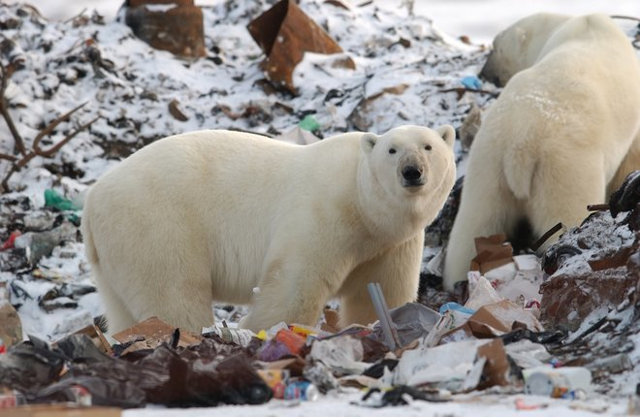
Belushya Guba is a settlement of about 2,000 people in Russia’s remote Novaya Zemlya archipelago, which is best known for its spooky plankton blooms and nuclear bomb tests.
Photos and videos posted over the weekend show the bears traipsing through empty schoolyards and even infiltrating the corridors of office buildings in search of food.
Polar bears are considered a vulnerable species around the world as global warming continues to diminish their sea ice habitats. As sea ice melts, polar bears have to travel farther and work harder to catch seals, causing some to starve to death in the process.

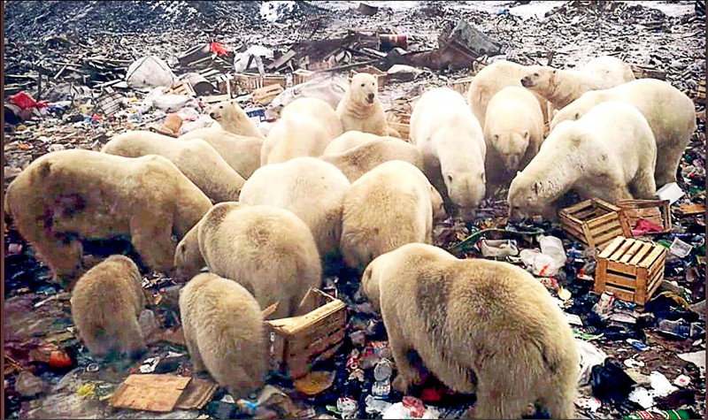

新聞辭典
Polar Bear：名詞，北極熊。
town：名詞，城鎮、市鎮。
Arctic：地名，北極。

文章網址：https://news.ltn.com.tw/news/world/paper/1268214
圖片網址：https://www.livescience.com/64741-polar-bears-are-taking-back-russia.html

