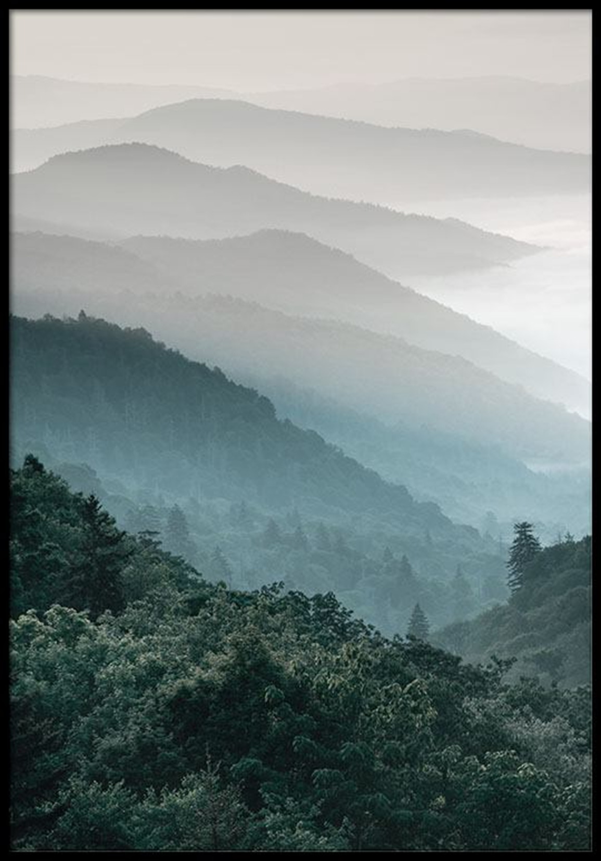
Scientists find massive Mayan society under Guatemala jungle
科學家在瓜地馬拉叢林下發現大型馬雅社會

Researchers using a high-tech aerial mapping technique have found tens of thousands of previously undetected Mayan houses, buildings, defense works and pyramids in the dense jungle of Guatemala’s Peten region, suggesting that millions more people lived there than previously thought.

The discoveries, which included industrial-sized agricultural fields and irrigation canals, were announced by an alliance of U.S., European and Guatemalan archaeologists working with Guatemala’s Mayan Heritage and Nature Foundation. The study estimates that roughly 10 million people may have lived within the Maya Lowlands, meaning that kind of massive food production might have been needed.

Researchers used a mapping technique called LiDAR. It bounces pulsed laser light off the ground, revealing contours hidden by dense foliage. The images revealed that the Mayans altered the landscape in a much broader way than previously thought; in some areas, 95 percent of available land was cultivated.
The 2,100 square kilometers of mapping done vastly expands the area that was intensively occupied by the Maya, whose culture flourished between roughly 1,000 BC and 900 AD. The mapping detected about 60,000 individual structures, including four major Mayan ceremonial centers with plazas and pyramids.
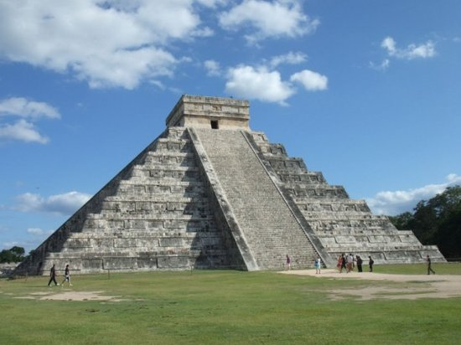

【Word bank】
map：繪製....地圖。
contour：輪廓。
flourish：繁榮、茂盛。

取自自由時報
http://iservice.ltn.com.tw/Service/english/english.php?engno=1177983&day=2018-02-21

