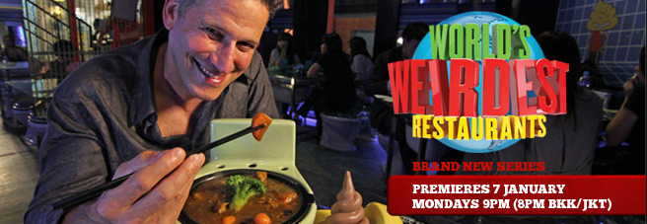

全球怪餐廳

Feel like dining out in a memorable restaurant? How about a place that’s off-the wall? With TLC’s new series The World’s Weirdest Restaurants, you can get a taste of what it’s like to eat out in some very bizarre places.
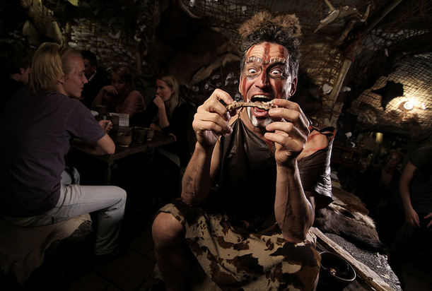
The first stop actually takes place here in Taiwan at Taipei’s Modern Toilet Restaurant. Inside, you’ll find that everything is themed around the unlikely toilet- not what you’d normally think of when you want to have something to eat. The seats are toilets, and the food is served in toilet bowls- no pun intended. Toilet lid hang on the walls, and drinks are served in bedpans. Even more unusual are the poop-shaped food covers and lighting fixtures. One would think this restaurant makes hungry plumbers feel right at home.
If you’d like to go back to a time when there were no toilets, a trip to the Pravek Restaurant in Prague, Czech Republic, will bring you back to the Stone Age. This restaurant has a caveman theme, and the chef serves meats with bones, just like caveman would eat. The décor is like a cave, the servers dress like prehistoric people, and there’s fun to be had for diners and workers alike. It’s part Stone Age, part steak house and part improv.
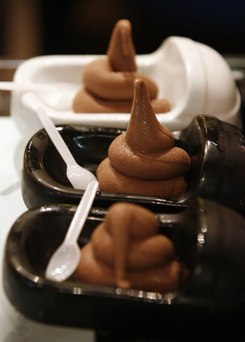
Sometimes dining out isn’t just about food. Instead, it’s about the experience. The World’s Weirdest Restaurants shows that some restaurateurs will go to any length to please their customers.
Word Bank
weird (adj.) 奇怪的,不尋常的 | caveman (n.) 史前石器時代穴居人
dine out 在外用餐,外食 | chef (n.) 主廚,廚師
memorable (adj.) 難忘的,值得懷念的 | décor (n.) (室內)裝潢風格
series (n.) 系列(節目),一連串 | improv (n.) 即興表演,即興創作
bedpan (n.) 便盆 | restaurateur (n.) 餐館老闆
fixture (n.) (房屋或建築內的)固定裝置 | go to any length(s) to V.  竭盡所能去…, 不易一切去…
feel at home 感到自在 | go to any length(s) to V.  竭盡所能去…, 不易一切去…
Reference: All Plus Interactive English Magazine

