Black: The Enduring Fashion
黑色時尚 經典永恆
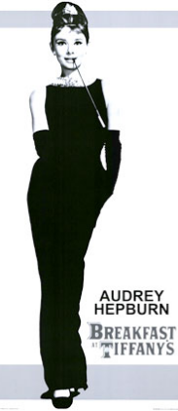
Black is contradictory. It is powerful yet humble. It can be noble or common. It’s the color of sophistication as well as simplicity. It is by its nature thought of as negative, and it has the ability to hide flaws. For centuries, black has been a driving force in the world fashion.
In 1926, Coco Chanel changed the place of black in woman’s wardrobes forever with the introduction of the little black dress. The dress was simple, allowing women to use accessories to show off their personal style. Audrey Hepburn made this style famous when she wore her black dress in Breakfast at Tiffany’s.
The 1950s saw black become a symbol of social, political, and intellectual rebellion in America. Black leather jackets became the uniform of members of the motorcycle gang Hells Angels, and the African-American political protest group, the Black Panther Party, dressed in all black, too. Beat poets may not have dressed in much leather, but the color many chose for their clothing was black.
By the end of the ‘80s, black was everywhere. From punk rockers to Madonna wannabes, from rappers to office workers, everyone relied on basic black. Today, black is the go-to color that never fails. As Christian Dior once said, “You can wear black ay any time. You can wear it at any age. You may wear it for almost any occasion.”
No other color has such power, and no other is so full of contradictions. You can wear black to stand out or blend in, to show authority or reject it, to provide luxury or display practicality. Though found everywhere, it’s still mysterious. Black never goes out of style.

Word Bank
contradictory (adj.) 相互矛盾的 | intellectual (adj.) 知識分子的,智力的
sophistication (n.) 文化修養;世故老練 | rebellion (n.) 反抗,叛亂
simplicity (n.) 樸素,簡單 | wannabe (n.) 效顰者,崇拜者
flaw (n.) 缺點,瑕疵 | go-to (adj.) (口語)非常可靠的
wardrobe (n.) 衣櫥,個人的全部服裝 | luxury (n.) 奢華
accessory (n.) 配件,飾物 | go out of style 退流行
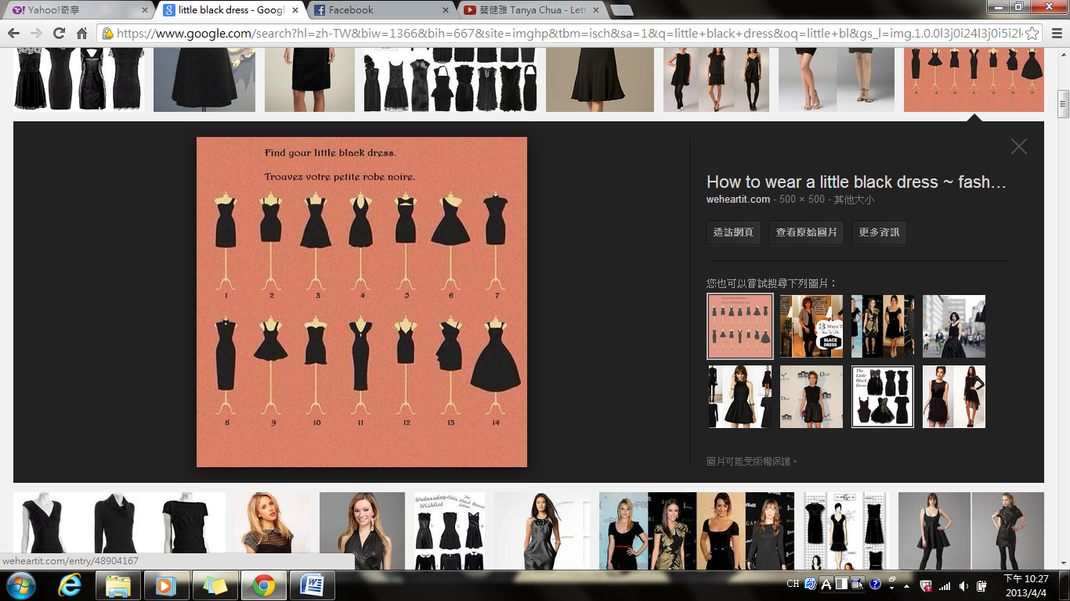

Reference: All Plus Interactive English

