Huge Lakes Thought to Be Hiding Beneath Antarctica’s Ice Seem to Have Vanished

南極冰面下應該藏著的巨大湖泊，似乎消失了
Antarctic researchers have long believed that large lakes lie hidden beneath the glacier in East Antarctica, trapped between the base of the ice and the bedrock of the Antarctic continent. A new study, though, failed to find any evidence of such large bodies of water.
This apparent lack of lakes is very weird. Without these bodies of water, researchers can’t easily explain other observations made about the ice, like the pockets where the surface of the ice rises and falls in cycles or the glacier’s flow toward the sea.

The glacier in question is an enormous river of ice in East Antarctica called Recovery Glacier; its basin stretches 621 miles (1,000 kilometers) inland from the sea and drains 8 percent of the volume of the East Antarctic Ice Sheet.
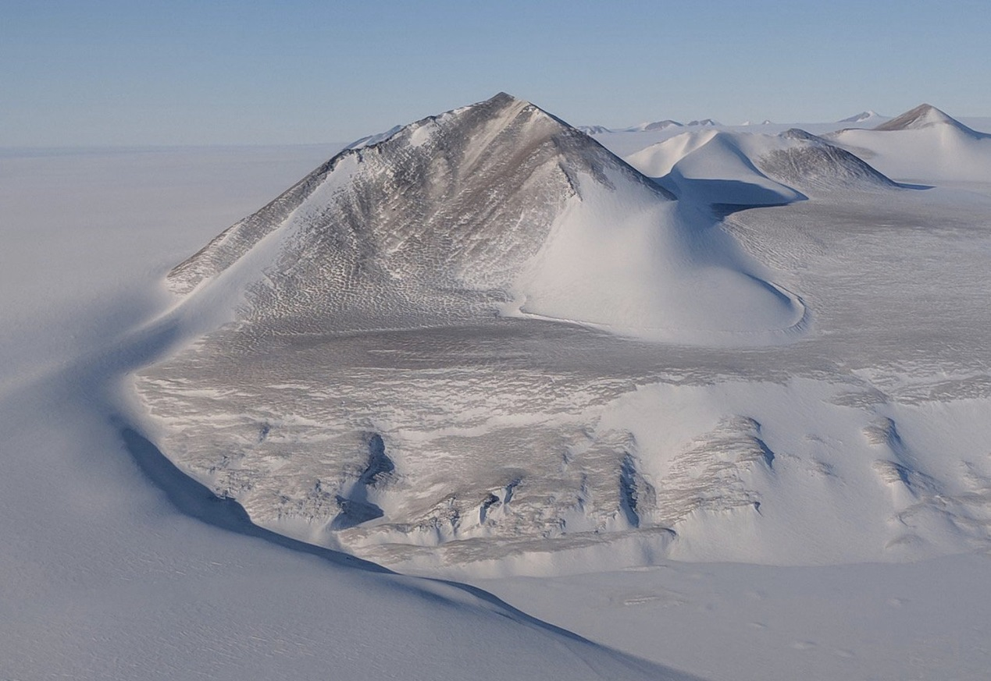

【Word Band】
ice sheet：名詞，冰蓋、冰層。
basin：名詞，盆地。
inland：形容詞，內陸的。

文章網址：http://iservice.ltn.com.tw/Service/english/english.php?engno=1246213&day=2018-11-12
圖片網址：https://www.livescience.com/64054-antarctica-subglacial-lakes-missing.html

