Seoul may develop nuclear-

powered submarine

首爾可能研發核動力潛艦
South Korea may develop its own nuclear-powered submarines or purchase them from the U.S. to better deal with North Korean submarine-launched ballistic missile （SLBM） threats.
A Cheong Wa Dae official said on condition of anonymity, "We may purchase the weapons or co-develop them with the U.S." Military sources here said the most realistic measure would be to purchase two to three U.S.nuclear-powered submarines first amid the North’s mounting SLBM threat, as the development and construction of such a submarine would take at least five years.
Sources said South Korean sailors would be able to learn skills and knowhow while operating the U.S. -made nuclear subs before the nation completes development and construction of its own subs.
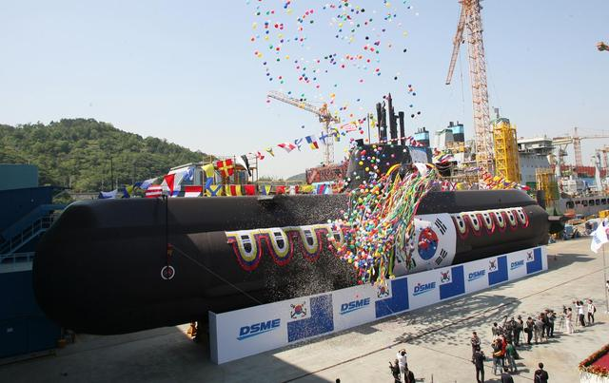
"Generally speaking, six to nine nuclear-powered submarines would be necessary to properly operate in the East, South and West Seas," a source said, asking not to be named.

【WORD BANK】
mount：動詞，上升、增加、爬（登、騎）上、鑲嵌。
operate：動詞，操（運）作、營運、開刀、作戰。
properly：副詞，適（恰）當地、充分地、正確地。

取自《自由時報》: http://iservice.ltn.com.tw/Service/english/english.php?engno=1151216&day=2017-11-12

