Anonymous Donor Gives Widower With 7 Children $10,000 for the Holidays

匿名者捐款1萬美元給有7個小孩的鰥夫好過節
Dakota Nelson has to work three jobs as he adjusts to life as a single parent to seven children, ages 1 through 16. In July, Nelson found his late wife, Ream, 38, unconscious and lying on the ground outside their home.
"We were working in the garage, goofing around and having fun, and [I] came back and she just was dead on the ground basically," Nelson told the East Idaho News.
Doctors said she had lacked oxygen to her brain for more than 20 minutes. She was in a coma for weeks before she passed away in September.
This Christmas, as the family still grapples with the loss, they will have something to smile about. East Idaho News showed up to Nelson’s home to surprise him with the $10,000.
Nelson’s jaw dropped as he saw all the zeros. The dad was overcome with emotion and burst into tears.
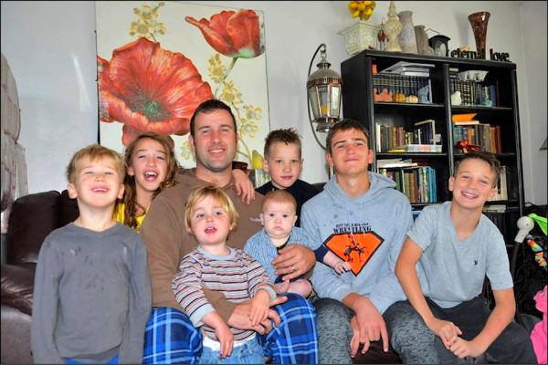
《新聞辭典》
goof around：片語動詞，非正式用法，閒蕩，瞎混。
grapple with：慣用語，盡力解決；設法對付；儘量克服。
someone’s jaw drops/dropped：慣用語，大吃一驚；驚訝得張口結舌。

文章網址：http://iservice.ltn.com.tw/Service/english/english.php?engno=1255628&day=2018-12-21
圖片網址：http://news.ltn.com.tw/news/world/paper/1255628

