Political divide poses challenge for inter-Korean summit

南韓社會的政治分歧對兩韓峰會造成挑戰

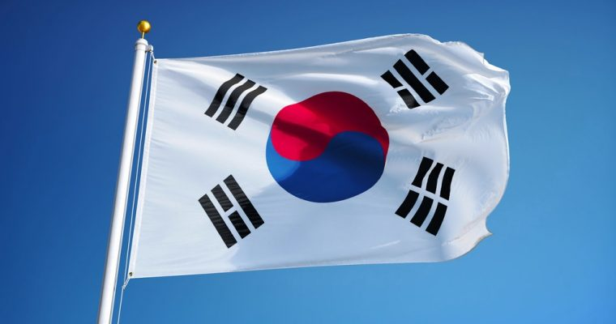
As the South Korean government considers ways to create the "right conditions" for the inter-Korean summit proposed by the North, a sharp divide in South Korea remains a challenge for the government.

Liberals hailed the invitation as a diplomatic breakthrough while conservatives dismissed it as a charm offensive by Pyongyang aimed at undermining the Seoul-Washington alliance and international sanctions against it. Conservative parties opposed any inter-Korean summit that would not result in denuclearizing the North. The divide reflects hope, frustration and indifference in Korean society over what could be the third inter-Korean summit.

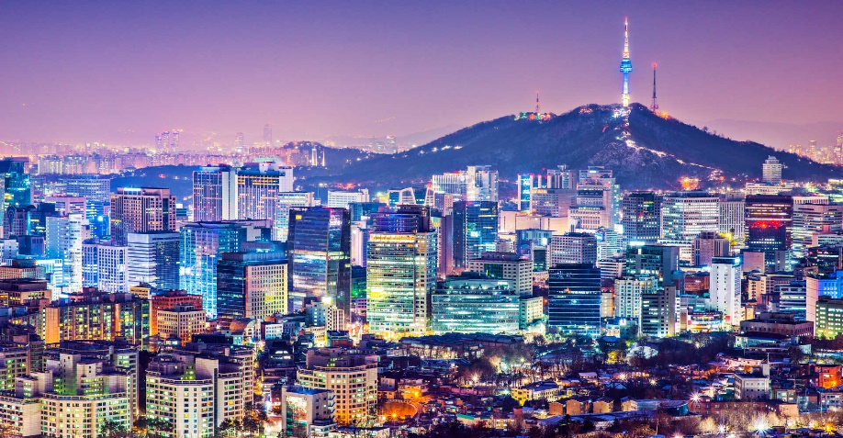
"The issues surrounding North Korea have been used for political purposes by politicians due to the long division between two Koreas," said Koh Yu-hwan, professor at Dongguk University. "The June 13 local elections will be the most important factor in shaping inter-Korean relations," said Lee Woo-young, professor at the University of North Korean Studies.

《Word Bank》
hail：動詞，為…歡呼（喝采）、招呼致意、吹捧、歌頌。
dismiss：動詞，解（遣）散、消除、駁回。
due to：片語，由於、因為。

取自《自由時報》http://iservice.ltn.com.tw/Service/english/english.php?engno=1177659&day=2018-02-18

