The future meat?
未來的肉如何發展?
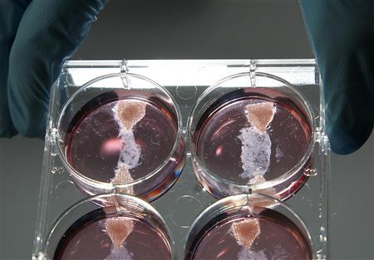
At first, it may sound hard to believe: Someday, we will eat meat that has not come from animals raised on farms, but from laboratories. As unlikely as it may seem, scientist are already getting closer to making this possible.
Some people may ask why anyone would want to bother to cultivate meat in the first place. The answer can partly be found in the planet‘s growing population. By most estimates, earth’s population will be around nine billion people by 2050. According to the United Nation’s Food and Agriculture Organization, meat production will have to double by that time to feed all of the hungry people around the world. Therefore, finding new ways to produce meat has actually become necessity.
What’s more, experts say that producing meat in a laboratory will benefit the environment. Believe it or not, livestock contribute greatly to global warming. Some estimate that methane that these emit during digestion account for up to 18 percent of green house gas emissions. In addition, the clearing of land for gazing adds further to the world’s environmental problems. Deforestation can cause soil erosion and the runoff from gazing land can pollute rivers. If more meat can be produced artificially, then more of this land can be returned to its natural state.

Vocabulary
1. cultivate v. 培養 栽培
2. emit v. 散發(光 熱 氣體 聲音等)
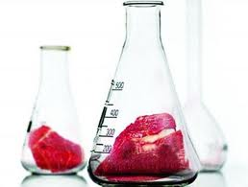
3. graze v. 放牧; (牛 羊) 吃草
4. erosion v. 侵蝕 腐蝕

Adapted from All Plus interactive English Magazine July 2012 – Celia Lin

