Homeless man saves life of pastor who took him in
遊民救了收留他的牧師性命

Here is a saying’ one good turn deserves another’ - and in Pastor John Greenaway’s case, it has proved to be true.

He and his family gave shelter to a homeless man in 2016, after a chance meeting in a book shop.

Belfast man Melvin Boyd had fallen on hard times, but said once he met Pastor Greenaway’s family and began living with them, his life changed. In turn, Boyd changed a life when he offered the pastor, who needed an organ transplant, one of his kidneys.

Boyd said living on the streets was difficult and that he could not trust anyone. After meeting the pastor’s son, who brought him to the family home, the Greenaway family helped Boyd to beat his alcohol addiction and start over.

Pastor Greenaway said： "I believed Melvin needed a new start in life, we wanted to help him" Since then, Boyd has stayed at the family home every day and night, and has become another son to the pastor, and his wife, who already have four children.

Last March, he repaid the pastor for his generosity by donating one of his kidneys to him. Pastor Greenaway had kidney failure and had been on dialysis for almost a year before the operation. That’s when Mr Boyd stepped in. He said： "There was no agonising about it. I believe it was meant to be."

【Work Bank】
take in：收留。
in turn：轉而、反過來。
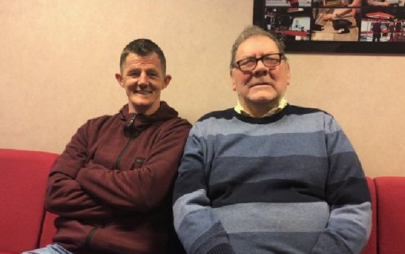
start over：重新開始。

取自自由時報
http://iservice.ltn.com.tw/Service/english/english.php?engno=1181793&day=2018-03-07

