Hong Kong’s new fight against ’fast fashion’

香港打擊「快時尚」的新運動
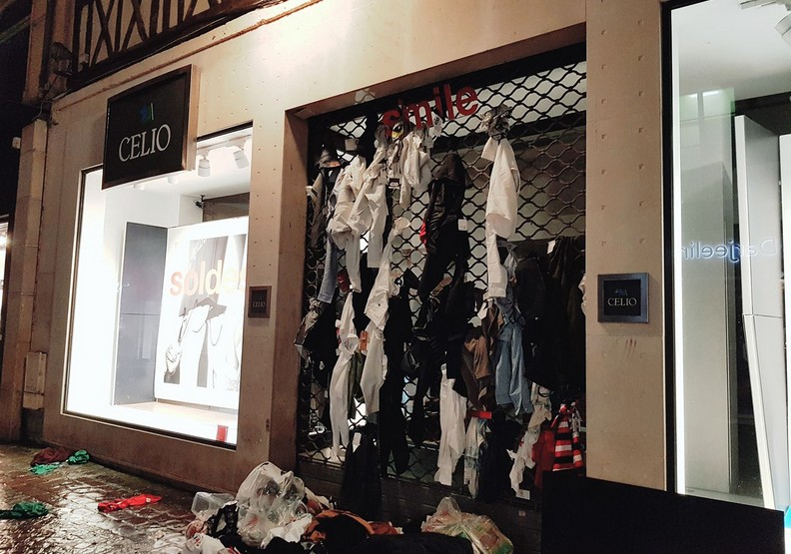
Despite Hong Kong’s reputation for rampant consumerism, a nascent movement against fast fashion is taking root in the city, with clothes-mending workshops and pop-up swaps growing in popularity, and designers parading recycled fabrics on the catwalk.
From broken umbrellas to discarded curtains, no material is too shabby for designer Jesse Lee, who showcased his creations at a sustainable fashion show in Hong Kong.
Lee realized that humble household goods could be the springboard for creativity when his family was throwing out an old sofa. He turned the sofa’s leather cover into a jacket and has since made clothes from old curtains and bed linen, as well as a raincoat using umbrella fabric.
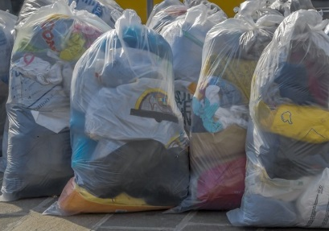
Global consumers purchased 60 percent more clothing in 2016 than in 2000 and only kept each item half as long, a report by McKinsey consultancy found. A 2016 report by Greenpeace also found a sixth of clothes owned by residents in Hong Kong were seldom or never worn after purchase.
《新聞辭典》
rampant：形容詞，猖獗的。
shabby：形容詞，破舊的。
springboard：名詞，跳板；出發點。

文章網址：http://iservice.ltn.com.tw/Service/english/english.php?engno=1255376&day=2018-12-20
圖片網址：https://www.gvm.com.tw/article.html?id=44315

