Disneyland Paris apologizes for banning boy from princess day

巴黎迪士尼為禁止男孩參加公主日致歉

Three-year-old Noah McLean-Glass is a Frozen "super fan," who loves nothing more than dressing up as Elsa.

His mother Hayley planned on booking the "Princess for a Day" package for her son as an early Christmas present, which includes a makeover and photo-shoot, but received an email from Disney refusing the request.

Disneyland Paris wrote: "At this time it is not possible to book Princess for a Day for a boy. However, we would be happy to arrange a gift pack with some Princess-themed items such as a cuddly toy, playset, etc. for a total price of 300 euros."
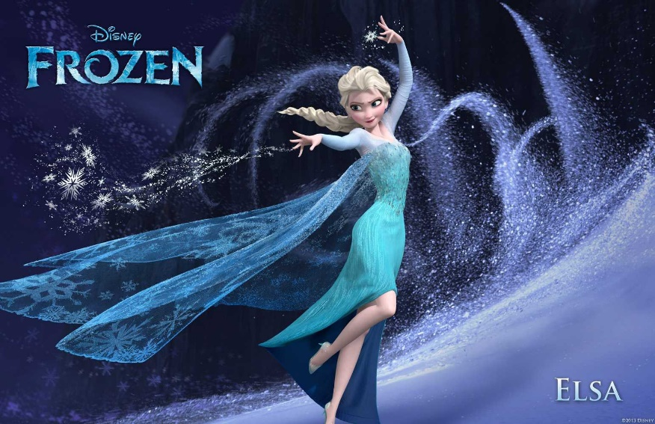

Hayley penned an open letter to Disney: "so let me get this straight, my son, who fell in love with Disney Princesses, is not allowed to have the same experiences as the little girls?"

"Please do explain to me what terrible awful fate may befall him if you indulge him in his desire to have his hair done, put on an Elsa dress and wear a bit of blusher for a photo?"

Disneyland Paris has expressed remorse for the family for providing them with inaccurate information and reinstated that this experience is available to all children ages 3 to 12.
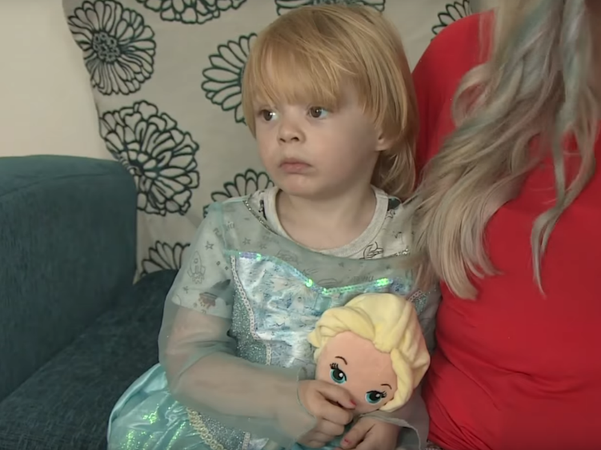

【WORD BANK】
makeover：名詞，美容、改造。
cuddly：形容詞，毛茸茸的。
befall：動詞，降臨於。

文章網址：http://iservice.ltn.com.tw/Service/english/english.php?engno=1154274&day=2017-11-23
圖片網址：http://www.eonline.com/news/877019/disneyland-paris-apologizes-for-banning-little-boy-from-princess-for-a-day-experience

