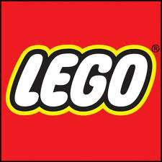
Megafactories:
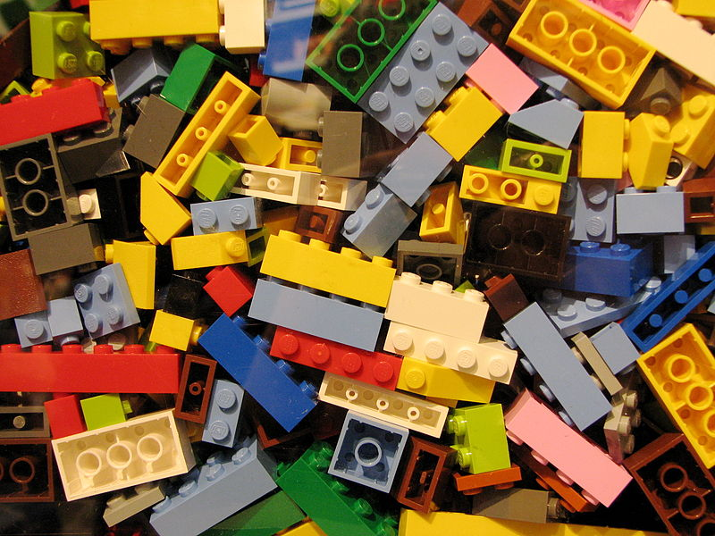
超級工廠-樂高積木
You’ve probably played with Lego bricks before. Think of what they look like. They’re just small, rectangular pieces of plastic. Most have eight studs on the top, and eight holes in the bottom. They’re simple, right?
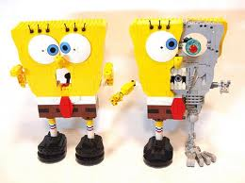

Wrong! Making Legos is a science. Engineers design every new kind of brick. They pick the brick’s size, shape, and color. They must also make sure that the bricks are safe for kids. After that, children play with the new bricks. If the kids kike the bricks, the company might sell them to the world. If the kids think they’re just so-so, then the company has more work to do.
Lego makes about 36 billion bricks every year, and sells seven toy sets every second. Since 1934, Lego has made more than 400 billion bricks. These days, there are also Lego movies, TV shows, and computer games. Lego is growing all the time, but people still love its bricks the most. You can use them to build almost anything. With six basic Lego bricks, you can make more than 915 billion combinations. 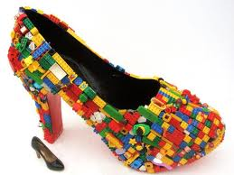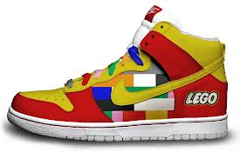
*Word Bank*
rectangular (adj.) 長方形的 | shape (n.) 形狀
plastic (n.) 塑膠製品 | billion (n.) 十億
bottom (n.) 底部,底端 | build (v.) 建造
design (v.) 設計 | basic (adj.) 基礎的
-source by National Geographic

