Robots serve up food and fun in Budapest cafe

機器人在布達佩斯咖啡館上菜及提供歡樂
The robots at the Enjoy Budapest Cafe can do it all - they can serve up food and drink, tell jokes, dance with the kids or just hang out for a chat with customers.
The cafe, opened by IT company E-Szoftverfejlesztő in the Hungarian capital, is staffed by a whole team of robots that aim to help familiarize the public with the technological revolution in automation and artificial intelligence.
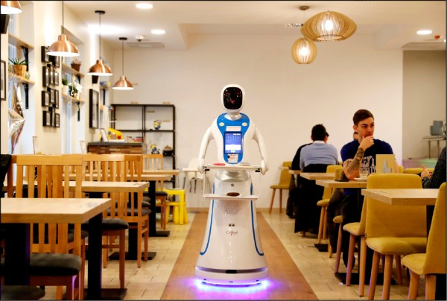
The robot waiters follow fixed paths to deliver food and drink orders to customers, who are asked to keep out of the robots’ way.
Others serve up entertainment, such as Pepper, a "receptionist" robot that can hold a conversation and also dance with customers.
Despite fears that increasing automation and artificial intelligence will take away employment from humans, Enjoy Budapest Cafe’s robots aren’t putting anyone out of a job yet.
"We actually employ twice as many people as before, because to operate 16 to 20 robots from 9 a.m. to 9 p.m. we need to have IT specialists in the background,"owner Tibor Csizmadia says.

【WORD BANK】
serve up：片語動詞，指端上、提出。
familiarize：動詞，指使熟悉、使親近、使普及、使家喻戶曉。
put out：片語動詞，指關燈、熄滅、撲滅、伸出、脫臼、大量生產、發出資訊、導致算錯、外包工作。

文章網址：http://iservice.ltn.com.tw/Service/english/english.php?engno=1265707&day=2019-02-02
圖片網址：https://news.ltn.com.tw/news/world/paper/1265707

