Cow Who Escaped Slaughter And Swam To Island Dies After Recapture

逃脫屠宰並游到荒島求生的母牛，在被捕回後死亡
A cow in Poland celebrated as an icon of freedom for her dramatic escape from slaughter has died from stress after being recaptured.
The red Limousin beef cow was caught Thursday near the village of Siestrzechowice and loaded onto a truck, but she died during transportation, The Associated Press reports.
Her escape, which happened on Jan. 23, garnered attention worldwide after being reported by Polish website Wiadomosci in February.

Workers were leading her towards a slaughterhouse-bound truck in southern Poland near Lake Nyskie. The cow fled, smashing through a metal fence and breaking the arm of a farm worker. She then dove into the water and swam out to an island in the middle of the lake. There, she managed to evade capture for weeks.

Her fans included Polish politician Pawel Kukiz, who told Sky News, "If all citizens could show such determination as this cow then Poland would be a much more prosperous country."

In the end, it took a team of five people and three shots of sedatives to recapture her. According to the AP, had she lived, she would have been "kept" at "a local governor’s farm," though it’s not entirely clear what her fate would have been there.

《World Bank》
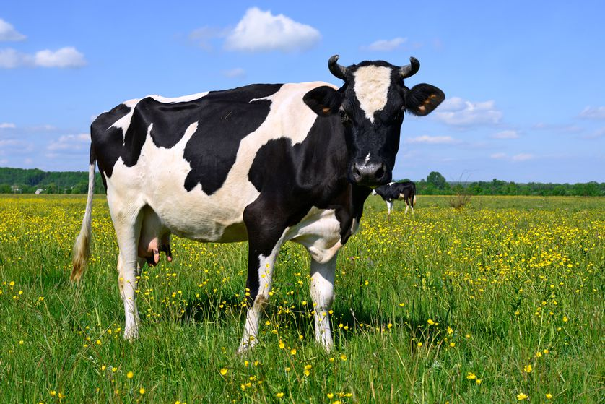
recapture：再捕獲、再現。
load：裝載。
garner：獲得。

取自《自由時報》http://iservice.ltn.com.tw/Service/english/english.php?engno=1179854&day=2018-02-28

