Man with ’golden arm’ whose rare blood saved more than two million babies donates for final time
罕見血液拯救逾200萬寶寶生命的「金臂」男最後一次捐血

An Australian blood plasma donor who has helped millions of mothers and their newborn children over the past several decades has made his final donation.

James Harrison, 81, has an antibody in his blood that is used in the production of Anti-D, a medication that prevents Hemolytic Disease of the Newborn. The potentially fatal condition can cause anemia, liver and spleen enlargement, brain damage, heart failure and even death in newborns.

Anti-D injections keep a pregnant woman who is Rh(D)-negative from developing antibodies in her immune system that could harm an Rh(D)-positive baby. Approximately 17 percent of pregnant women in Australia need the injections, which come from a pool of less than 200 Australian donors.

Harrison made his 1,117th and final donation on Friday, May 11, after a six-decade blood-donation span that helped an estimated two million Australian women and their babies.

Dubbed the "man with the golden arm," Harrison underwent a heart surgery when he was 14 and required blood transfusions to save his life. He began donating his blood as soon as he was old enough to, and later became the pioneer of a country’s Anti-D program.
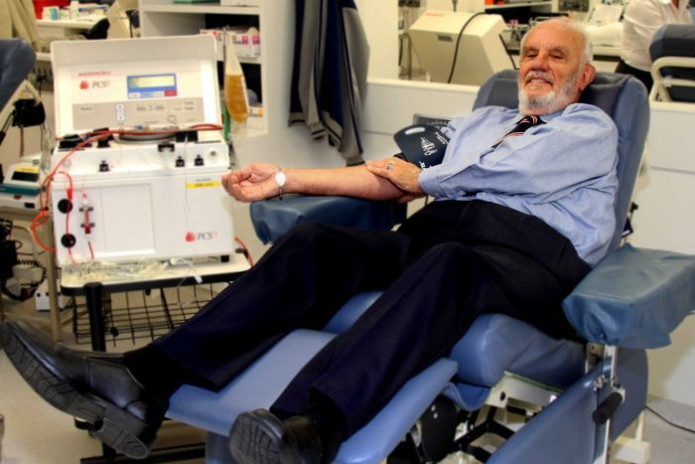
【Word Bank】
a pool of：一灘、一片。
enlargement：擴大、腫大。
transfusion：輸血、輸液。

取自自由時報
http://iservice.ltn.com.tw/Service/english/english.php?engno=1213942&day=2018-07-04

