Senators call for Trump to fill vacant Korean-affairs posts promptly

參議員呼籲川普立即補實兩韓事務職位空缺

10 US Democratic senators has urged US President Donald Trump to quickly fill major posts in charge of Korean affairs that have been vacant for months, given escalating tensions on the Korean Peninsula, Voice of America reported Thursday. The senators made the demand in a joint letter, saying it is very worrisome that the posts are still vacant despite the tensions.

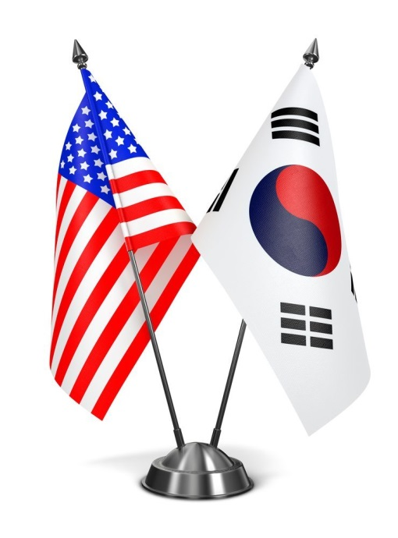
The roles the senators pinpointed are ambassador to South Korea and assistant secretaries of both state and defense for East Asian and Pacific affairs. They have remained empty for the eight months since Trump’s inauguration in January.

The senators called for Trump to appoint talented figures with extensive careers in the North Korea and Asia sectors to the posts, underlining that they play key roles in fine-tuning US diplomatic and defense policies on the region.
They also stressed that the vacancies should not be kept open long, so that new appointees can closely coordinate on measures to implement the sanctions on North Korea recently adopted by the UN Security Council. They reminded the president that South Korea is one of America’s most valued allies.
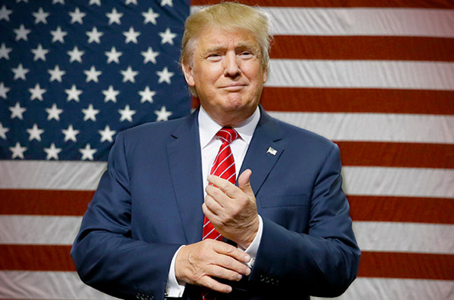

【WORD BANK】
call for：動詞片語，呼籲、要求、需要。
pinpoint：動詞，明確指出、精準標出方位（、範圍、原因）。
fine-turn：動詞，調整、微調。

文章網址：http://iservice.ltn.com.tw/Service/english/english.php?engno=1137897&day=2017-09-24
圖片網址：http://agnetwest.com/south-korea-wants-step-by-step-approach-to-korus/
http://www.chineseofchicago.com/Content.aspx?nid=8727

