Galapagos bans fireworks to protect unique wildlife
為保護獨特的野生動物，加拉巴哥禁放煙火

Fireworks have been banned on the Galapagos Islands to protect the archipelago’s unique fauna, the local government said.
The local council said in a statement that it had agreed "unanimously a resolution that prohibits the importation, sale, distribution and use of fireworks in the Galapagos province." Those fireworks that produce light but no noise have been excluded from the ban.
The islands are home to thousands of residents as well as being a tourist destination, and the measure comes just days before New Year celebrations in which many people traditionally set off fireworks. It also wants to avoid any potential deterioration in air quality or pollution of water sources.
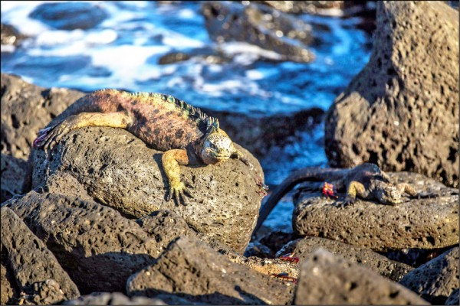
Animals have suffered from elevated heart rates, nervous stress and anxiety, which have "notably" changed their behavior and affected the survival of species inhabiting this World Heritage Site that belongs to Ecuador.
Known for its endemic species, the volcanic Galapagos Islands played a crucial role in British naturalist Charles Darwin’s studies before he came up with his theory of evolution.
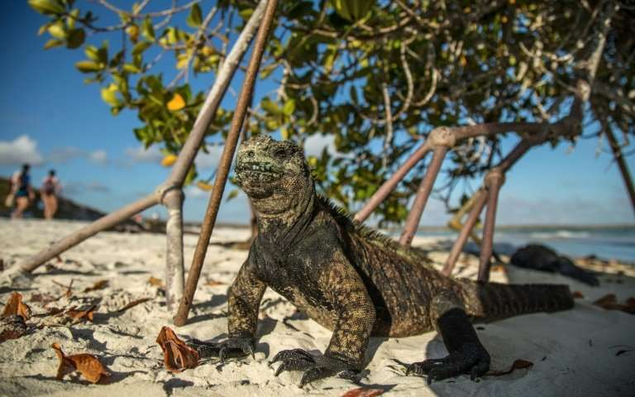

【Work Bank】
set off：動詞片語，觸發、引爆。
deterioration：名詞，惡化、退化。
come up with：動詞片語，提出、想出。

取自自由時報
http://iservice.ltn.com.tw/Service/english/english.php?engno=1258312&day=20

