**10-year-old boy delivers baby brother as his mother goes into labor early**

**媽媽提前分娩 10歲男孩親自接生弟弟**

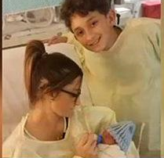 Ashly Moreau, from Sulphur, Louisiana, USA, woke up and went to the toilet on Friday morning, but she suddenly found her water had broken and her baby’s feet were coming out.

Moreau was home alone with her 11-month old daughter and 10-year-old son Jayden. Six weeks earlier than she was due, all she could do was call for her Jayden, who ran to the bathroom to see his mother bleeding and his new sibling’s feet - he was a breech baby.

Jayden decided to run to his grandmother’s house for help. She called the police, but since she just had surgery not long ago, she couldn’t get to Moreau herself.

Going back to his mother, Jayden asked his mom to tell him what to do. According to Moreau, he didn’t even look scared, but rather calm and brave.

He pulled the baby’s legs while his mother pushed, and after a few minutes the newborn boy was out.

An ambulance arrived afterwards and the doctor said that it is Jayden that saved the lives of both his mother and baby brother.



**【WORD BANK】**

deliver：動詞，接生、生（嬰兒）。

go into labor：慣用片語，開始分娩。

due：形容詞，預期的、到期的。

文章網址：<http://news.ltn.com.tw/news/world/paper/1152332>

背景網址：http://nihaoya.com/html/bbfede/