Ageism is everywhere
年齡歧視無所不在

Ageism is so common it may seem routine, trivial, well-intentioned. But it’s not necessarily harmless. Similar characteristics are interpreted differently by age. A teenager losing the car keys is momentarily careless, an older person is developing dementia

Compared with other common prejudices, ageism is rarely discussed. Everyday ageism is so widespread that people tend to use "young" and "old" as almost synonymous with positive-versus-negative traits.

Old people have become more segregated. Throughout most of human history, different generations usually lived together or nearby. But the Industrial Revolution lured younger people into cities for jobs, and urban living quarters couldn’t accommodate extended families, said Todd D. Nelson, a psychologist at California State University.
Nelson mentioned an even less obvious reason for the changing status of old people：the invention of the printing press. Before then, old people were respected sources of valuable knowledge handed down from earlier generations and accumulated through their years of experience.
【Word Bank】
ageism：名詞，年齡歧視。
prejudice：名詞，偏見、成見。
accommodate：動詞，容納、遷就。
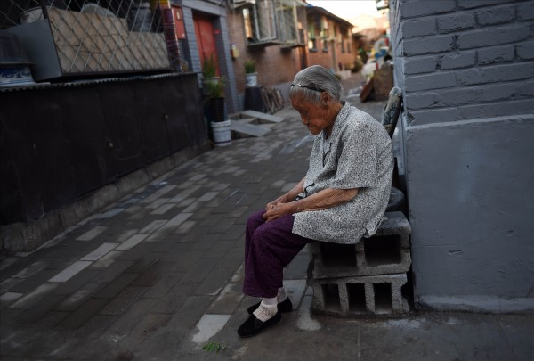

取自自由時報http://iservice.ltn.com.tw/Service/english/english.php?engno=1168807&day=2018-01-15

