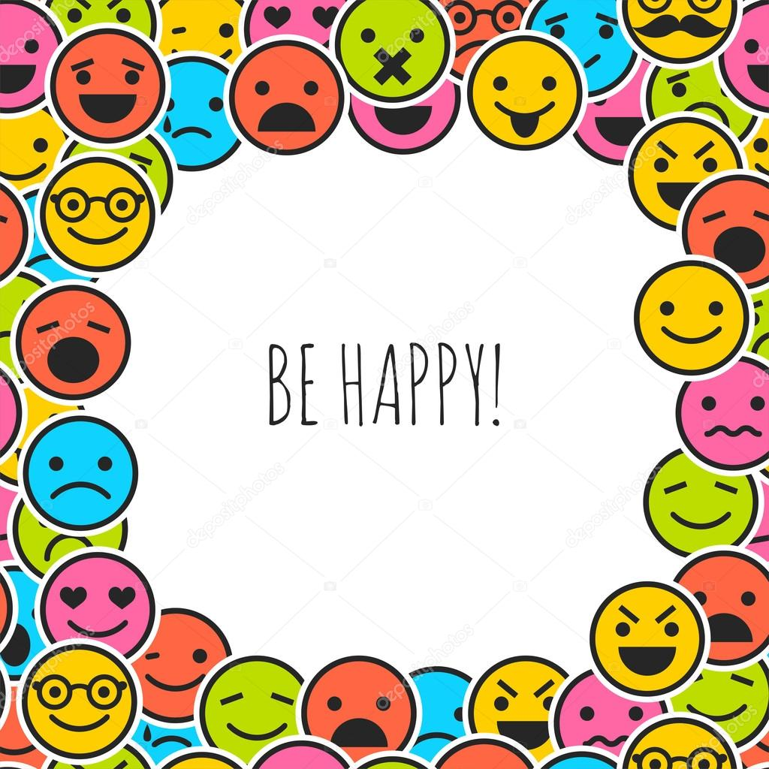
Using emoticons in work emails make you look incompetent

工作電郵中使用表情符號讓你看起來不適任
Keep the smiley faces out of your work
emails, or else the person receiving the
message may think you’re incompetent.
That’s according to a study published in "Social Psychological and Personality Science."
As emoticons and other visual representations of language make their way into traditionally text-based communications such as emails and text messages, Ella Glikson,along with co-authors
Arik Cheshin and Gerben A. van Kleef,
wanted tstudy the effect theemoticons
on themeaning of the message.
"I was very optimistic about the positive
power of emoticons. But our initial results surprised me. So we focused on the specific effect of smileys on first impression in work context, and our results were very consistent across different experiments," Glikson told
CNN in an email.

【WORD BANK】
incompetent：形容詞，無能力，無法勝任，不適任。
keep（sb/sth）out of sth：慣用語，（使）不參加；
（使）不捲入；（使）置身……之外。
make one’s way：慣用語，前進、取得成功。

取自《自由時報》: http://iservice.ltn.com.tw/Service/english/english.php?
engno= 1150722&day=2017-11-10

