
德國動物收容所禁止當作耶誕禮物的寵物領養

Dozens of shelters in Germany have told potential pet owners that no animals will be handed over in the run-up to Christmas. Berlin’s shelter, the largest in Europe, is among them.
It says the ban reduces unwanted animals being dumped back after the holiday period. "Animals are living beings with needs and feelings," it said. "They are not suitable as surprise gifts."
Regional news outlets are reporting similar decisions in other towns and cities, including dozens of shelters in an united decision in Lower Saxony.

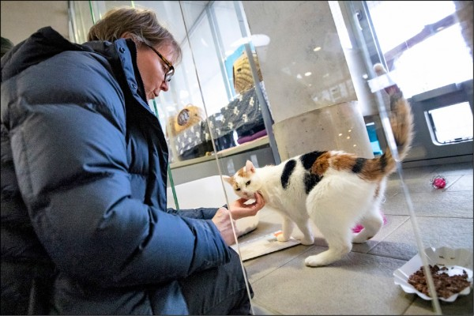

The problem, according to the ban’s supporters, is that pets are often bought impulsively at the last minute. "The decision to keep an animal must not be taken lightly - the whole family must be involved in the decision-making process," said Claudia Hämmerling from Berlin’s animal protection association.
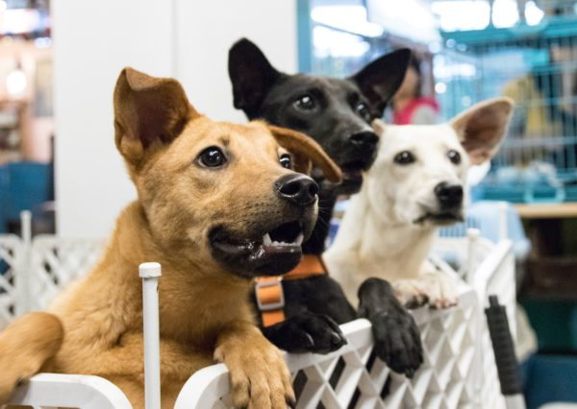

【Work Bank】
hand over：交出、移交。
the run-up to something：重大活動前的準備階段
the last minute：最後、最後一刻。

取自自由時報
http://iservice.ltn.com.tw/Service/english/english.php?engno=1255113&day=2018-12-19

