Effigies of ghosts, monsters spook visitors in Okayama

岡山的鬼怪與怪物芻像嚇壞遊客

Not for the faint of heart, a special exhibition of ghost and monster effigies being held at a museum in Okayama Prefecture, Japan is a case of high-brow art meeting low-brow artisanship.

On display at the "Setouchi Obake Geijutsu-sai", hosted by the Setouchi City Museum of Art in the Ushimado-cho of this western city, are works by Taishi Takemoto, a sculptor of monsters, and by Ichio Nakata, an artisan of haunted house dolls.

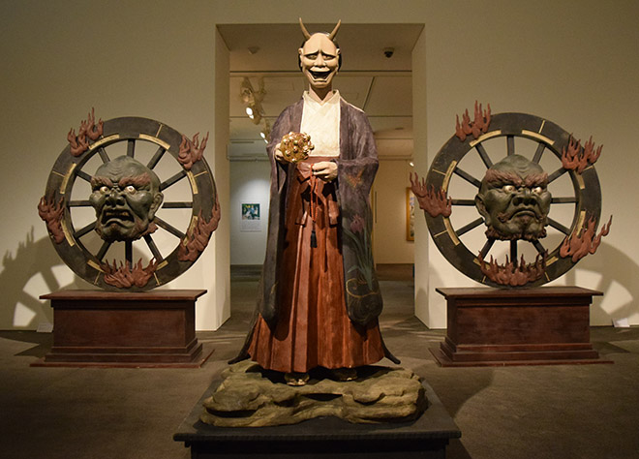

The exhibition is spotlighting artists whose cultural backgrounds and artistic styles couldn’t be more different.

Nakata, 91, who resides in Kurashiki, Okayama Prefecture, has spent about 80 years making dolls of ghosts for use at haunted houses, with inspiration drawn from pictures of ghosts, including ukiyo-e woodblock prints.

《WORD BANK》
fainthearted：形容詞，膽怯的，怯懦的；
not for the fainthearted/not for the faint of heart：片語，不適合膽小的人。
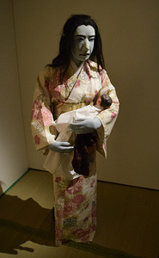
highbrow/lowbrow：形容詞，嚴肅高雅的，菁英的／庸俗的，庶民的。
spotlight：動詞，以聚光燈照亮；使受到矚目。

文章網址：http://iservice.ltn.com.tw/Service/english/english.php?engno=1158471&day=2017-12-08
圖片網址：http://www.asahicom.jp/ajw/articles/images/AS20170815002685_commL.jpg
http://www.asahicom.jp/ajw/articles/images/AS20170815002684_comm.jpg

