Scientists create bee vaccine to fight off insect apocalypse

科學家創造蜜蜂疫苗，對抗昆蟲末日
Bees are vital for growing the world’s food as they help fertilize three out of four crops, by transferring pollen from male to female flowers. But in recent years, bee populations have been dying off from "colony collapse disorder."
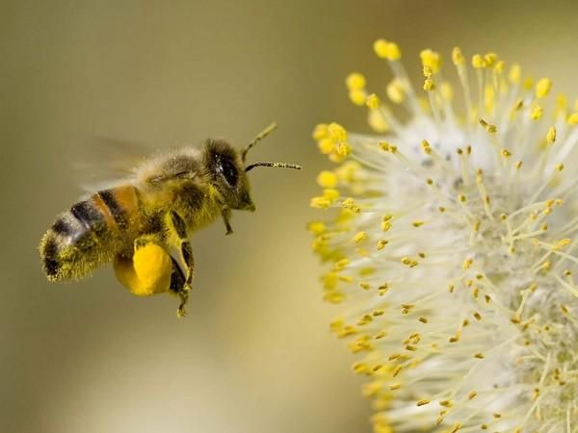
A team at Helsinki University in Finland has developed a vaccine, which they believe is the world’s first, to give bees resistance to fight off severe microbial diseases that can be fatal for pollinator communities.

Vaccinating insects was previously thought to be impossible because the creatures lack antibodies until Dalial Freitak, a specialist in insects and immunology, noticed in 2014 that moths who are fed certain bacteria can in fact pass on immunity to their offspring.
Heli Salmela was working on honey bees and a protein called vitellogenin at Helsinki U. and the pair started to collaborate to create a vaccine against American foulbrood. The treatment is administered to the queen bee via a sugar lump. The queen then passes the immunity to her offspring, spreading it through the bee community.
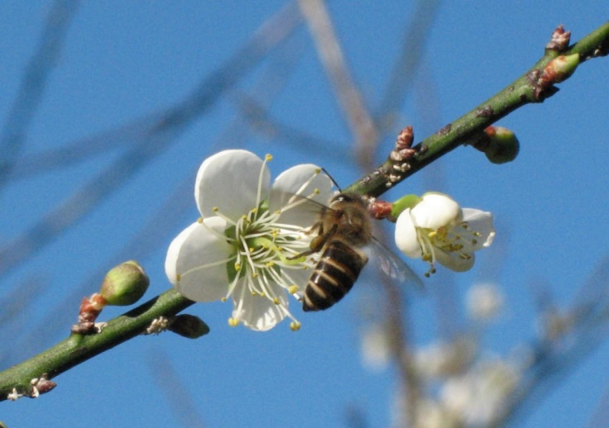
【WORD BANK】
pollen：名詞，花粉。
die off：動詞片語，相繼死去。
collaborate：動詞，合作。

文章網址：http://iservice.ltn.com.tw/Service/english/english.php?engno=1267352&day=2019-02-14

