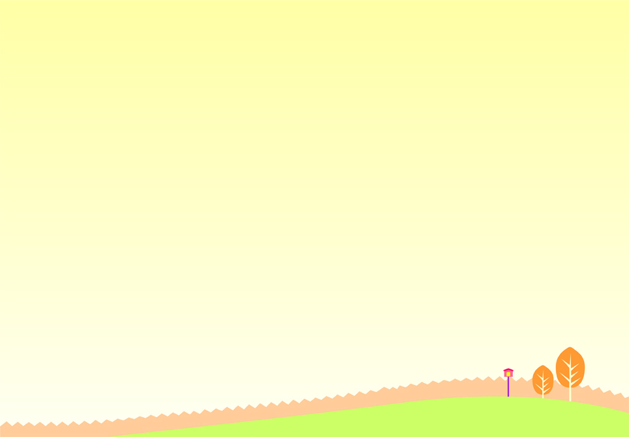
At Cambodia’s ’Rubbish school,’ children pay tuition with trash
在柬埔寨「垃圾學校」，學童用垃圾繳學費

Sitting in a building made from used tires, plastic bottles and old sneakers, Cambodian student Roeun Bunthon jots down notes during an English lesson at the "Rubbish School" where tuition is paid for with trash instead of cash.
Needy kids like Bunthon, a former street beggar, can take computer, mathematics and language classes － and learn the value of reducing waste in a notoriously polluted country.
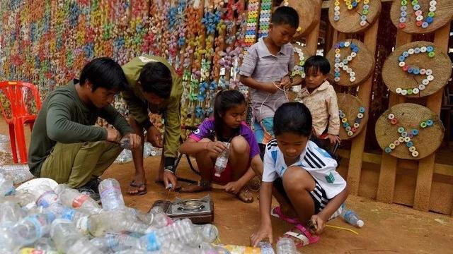
The Coconut School is built almost entirely from recycled waste and is the brainchild of Ouk Vanday, nicknamed the Rubbish Man, a former hotel manager who dreams of a trash-free Cambodia.

He plans to expand classes in the poor, agricultural province of Kampong Speu to accommodate 200 kids. He’s optimistic the young minds are environmental ambassadors in the making.
Cambodia accumulated 3.6 million tonnes of waste last year, with a mere 11 percent of that gets recycled, according to the country’s Ministry of Environment.
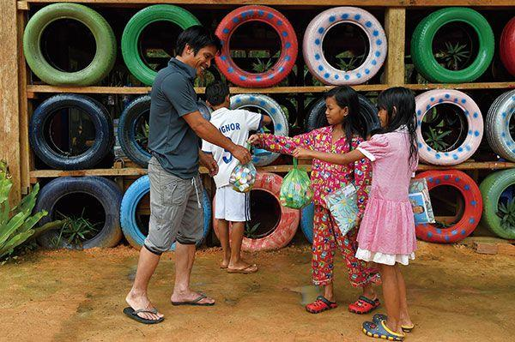

【Work Bank】
jot down：動詞，草草寫下。
brainchild：名詞，構思；主意。
in the making：慣用片語，在醞釀中。

取自自由時報
http://iservice.ltn.com.tw/Service/english/english.php?engno=1256973&day=2018-12-27

