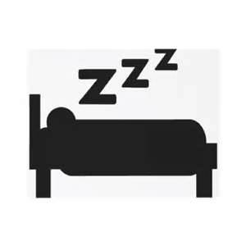
Sleep Makes the Teen
研究指出 青少年睡眠不足傷身又傷腦

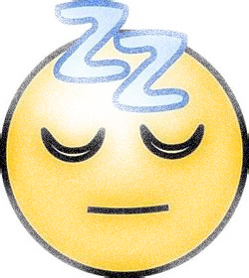
Everyone needs the proper amount of shut-eye, nobody more so than today's growing teens. But it is this group that is the most sleep-deprived and they are paying the price, according to a recent study.
A poll released March 28 by the National Sleep Foundation, a U.S. research group that studies sleep and sleep-related health issues, found that only 20 percent of adolescents get the recommended nine hours of sleep on school nights. One in four reported sleeping in class. The resulting lack of rest is having an impact on health and learning.
"Sleep serves not only a restorative function for adolescents' bodies and brains, but it is also a key time when they process what they've learned during the day," said Jodi Mindell of St. Joseph's University in Philadelphia and director of the Sleep Center at The Children's Hospital of Philadelphia.
According to the National Institute of Health, a person who does not get enough sleep has trouble focusing and responding quickly. There is also growing evidence linking chronic sleeplessness with increased risk of obesity, diabetes, heart disease and infections.
Nearly 28 percent of high school students in the survey said they fall asleep in class, while 22 percent doze off doing homework and 14 percent arrive late or miss class because of oversleeping. Eighty percent of students getting the recommended level of sleep report earning A or B grades in school. Those with less sleep were more likely to receive lower grades.

shut-eye n. 睡覺 sleep-deprived adj. 缺乏睡眠的
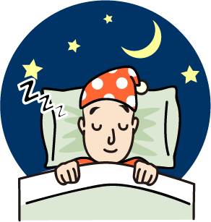
adolescent n. 青少年 restorative adj. 恢復健康的
sleeplessness n. 失眠；不眠 obesity n. 肥胖
diabetes n. 糖尿病 doze off 打瞌睡

oversleeping n. 睡過頭；睡得太久

