Superheroes and villains: Who’s more violent might surprise you

超級英雄及壞蛋：誰更暴力可能令您吃驚

Superheroes nearly always save the day, but the methods they use might not be heroic. A recent study suggests that superheroes are more violent than villains.
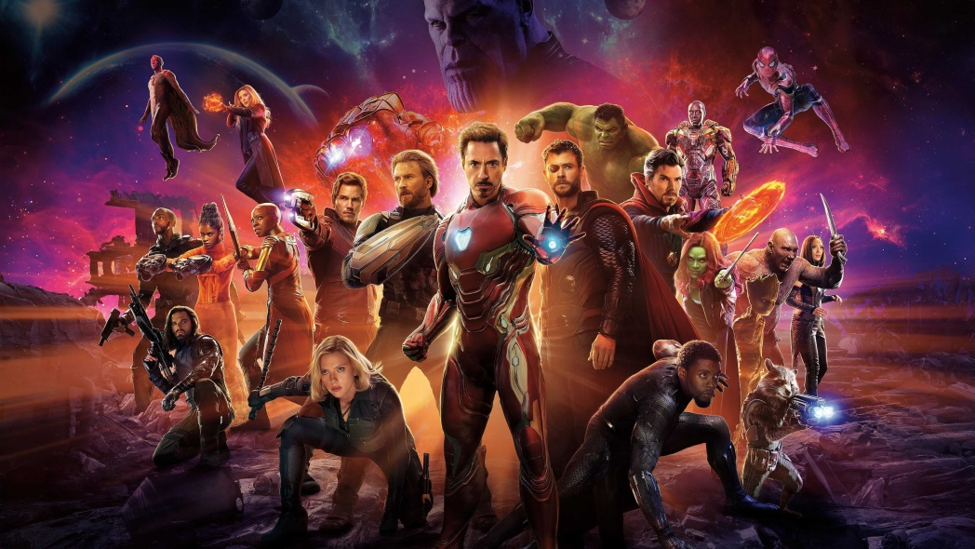
A group of researchers watched 10 superhero films from 2015 and 2016 with the highest gross (this included both Marvel and DC films) and separated characters as good guys (a.k.a. protagonists) and bad guys (a.k.a. antagonists). They then observed the actions of both groups.
The study found that superheroes performed an average of 23 violent actions per hour versus the 18 violent actions taken by villains. Superheroes were fighting at almost double the rate of villains including the use of lethal weapons as well as destroying property.
’The good guys’ may be setting youngsters a worse example than villains like Batman’s Joker. The researchers worry this may make children think brutal acts like murder are acceptable, as they urge youngsters not to emulate these heroes.
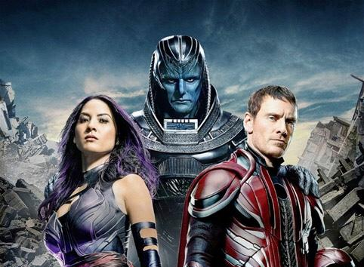

新聞辭典
villain：名詞，壞蛋、惡棍、反派角色。
save the day：動詞片語，轉危為安、扭轉頹勢。
a.k.a.：also known as的縮寫，又稱、亦稱。

文章網址：http://iservice.ltn.com.tw/Service/english/english.php?engno=1251573&day=2018-12-04
圖片網址：http://www.twoeggz.com/news/12064821.html

