INDIGENOUS INDUSTRY
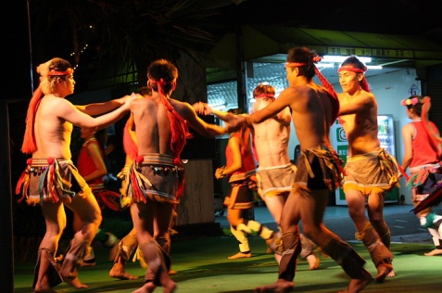
台灣原住民文化傳統的未來
NINA DOS SANTOS, CNN ANCHOR
Taiwan’s indigenous people have long been left behind amid the island’s economic boom. Now, as Paula Hancocks reports, things are changing. Some indigenous communities are turning into their way of life into a business, and also trying to ensure that their traditions live on.
PAULA HANCOCKS, CNN CORRESPONDENT
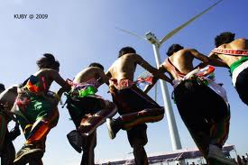
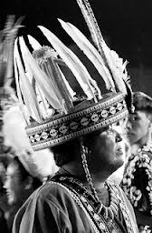
The oldest woman in Kayu village sings to one of the youngest, teaching her the songs of Taiwan’s Atayal tribe. Lawa Oyu’ is 88 years old. She dressed in traditional clothes and speaks the Atayal language, hoping to preserve the culture of her indigenous tribe.
“The traditions of our village and society, and the spirit of our ancestors are not passing to the next generation,” she tells me. “Our young people are facing a dilemma between adapting to modern society and retaining traditional values. I’m really worried.”

Word Bank
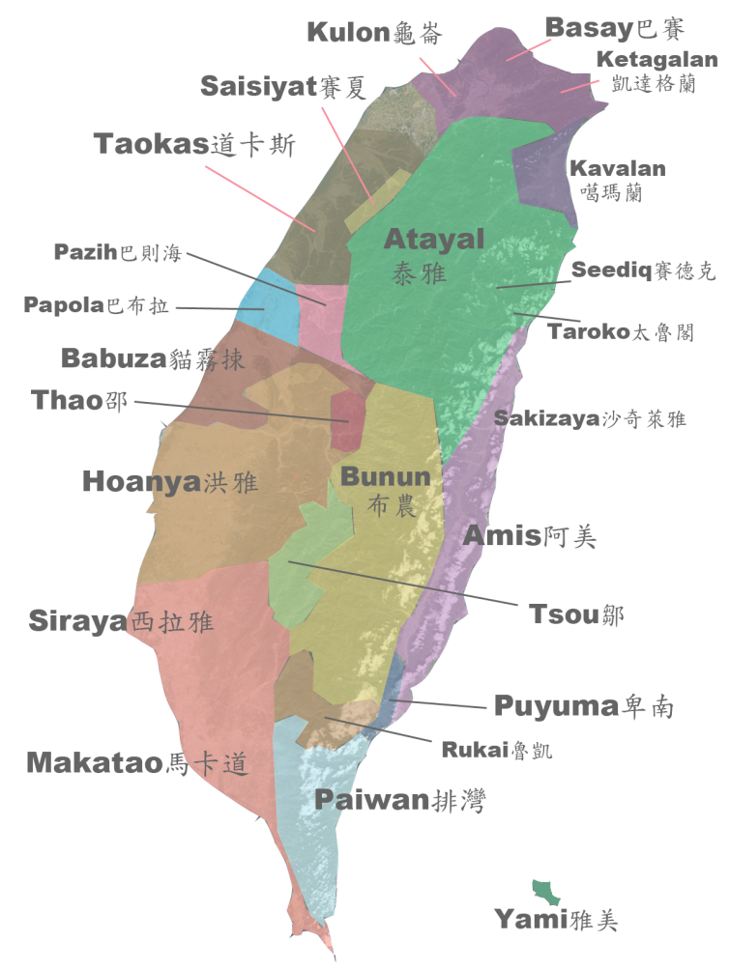
indigenous(adj.) 原住民的,土生土長的
leave behind 遺忘,遺留
boom(n.) 激增
ensure(v.) 確保,擔保
ancestor(n.)祖先,祖宗
dilemma(n.)進退兩難的局面,窘境
adapt to 適應於
retain(v.)保有,留住

Source: CNN Interactive English Magazine

