Sheep can learn to recognize human faces, research shows

研究顯示，羊能學習辨認人臉
Sheep learned to recognize four celebrities after being shown their pictures, according to a new study, suggesting the woolly animals have face-recognition abilities similar to humans and primates.
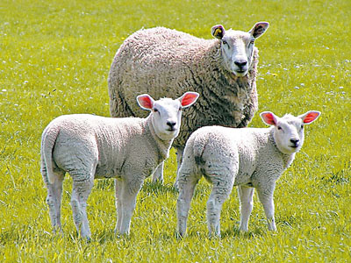
In the study published in the journal Royal Society Open Science, scientists trained eight sheep to recognize the faces of former president Obama, "Harry Potter" actress Emma Watson, British TV host Fiona Bruce and American actor Jake Gyllenhaal. Previous research had already shown sheep can recognize other sheep and familiar humans, but little was known if they can recognize unfamiliar faces from two-dimensional photographs.

In the experiment, scientists trained the sheep using food incentives to recognize the celebrity faces from a frontal photo of each. They then challenged the sheep by presenting two photographs and rewarded the sheep with food if they chose that of the celebrity.
Researchers also tested whether sheep could still recognize the learned face if it was at a different angle. Sheep were able to perform this task at about 66 percent, which the researchers said was "a magnitude similar to that seen when humans perform this task."

【WORD BANK】
two-dimensional：平面的、缺乏深度的。
incentive：刺激、獎勵的。
magnitude：數量、範圍、地震規模。

取自《自由時報》: http://iservice.ltn.com.tw/Service/english/english.php?engno=1153980&day=2017-11-22

