’The Wizard of Oz’ Is the Most Influential Movie of All Time
《綠野仙蹤》是史上最具影響力電影

The Wizard of Oz is the most influential film of all time, followed by Star Wars, Psycho and King Kong, according to a study.
Researchers at the University of Turin in Italy calculated an influence score for 47,000 films listed in the internet movie database (IMDb). The results showed that the top 20 most influential films were all produced before 1980, mostly in the US.
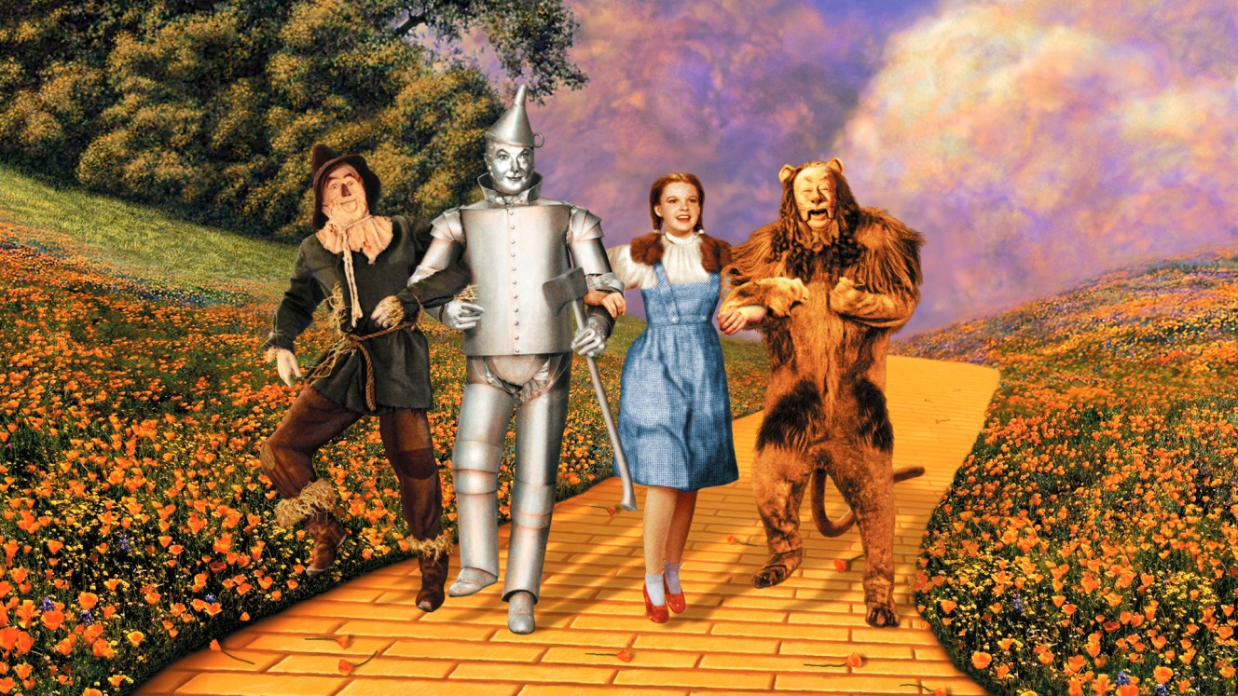

The Wizard of Oz, starring Judy Garland and premiered in 1939, topped the list. It has been referenced in almost 3000 other movies, including its iconic songs like Over The Rainbow, and its most famous line ’I’ve a feeling we’re not in Kansas anymore.’
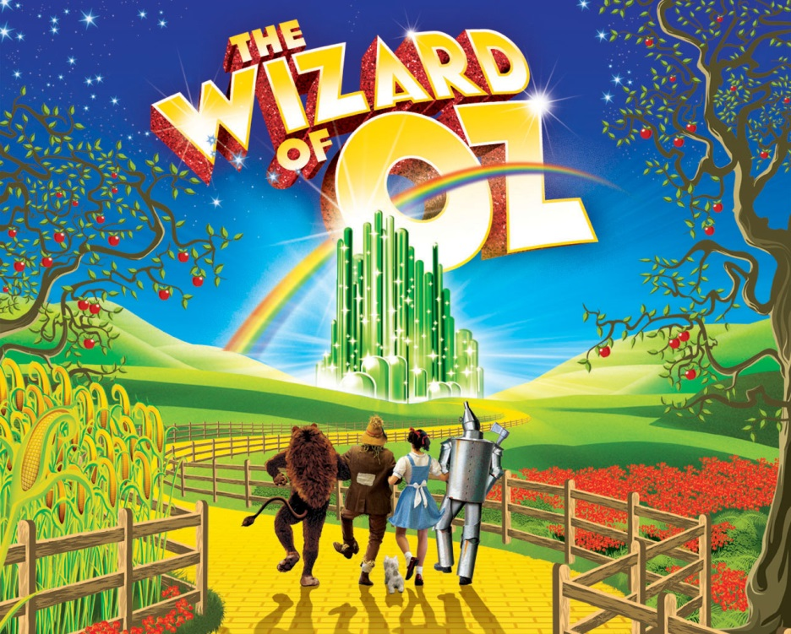
Applying the same algorithm to actors, it found that Samuel Jackson, Clint Eastwood and Tom Cruise, Arnold Schwarzenegger and John Wayne made up the top five.

《新聞辭典》
star：動詞，由…主演（及物動詞）；（註：做為不及物動詞時，寫成star in/at，意為主演某部戲劇）。
premiere：動詞／名詞，首演、首映。
line：名詞，台詞。

文章網址：http://iservice.ltn.com.tw/Service/english/english.php?engno=1256544&day=2018-12-25

