Electoral College
美國選舉人團制度
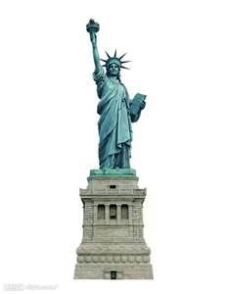

What is the Electoral College? Established by America’s Founding Fathers, it’s actually a process, not a place. It’s even in the Constitution, described as a compromise somewhere between a vote in Congress and popular vote of the people. Each state has a number of electors, based on how many members it has in Congress. So, a state with a lot of people like California has 55 Electoral votes. A small state like Delaware has just three. States award their electoral votes on the basis of the popular vote. In most states, it’s winner take all. And it takes a majority-270 of the 538 total electoral votes- to win the presidency. After the November election, members of the electoral college meet to cast their ballots. The results are sent on to Congress, which tallies the vote and then makes it official.

By the way, the candidate who wins the popular vote doesn’t always win the election. In the year 2000, more Americans voted for Vice President Al Gore, but George W. Bush had more electoral votes. So, he prevailed and won the presidency. You can’t win the White House without it: the Electoral College.

*Vocabularies*
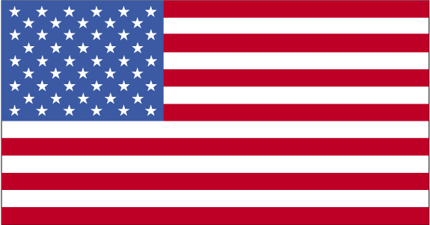  Constitution | (n.)憲法;章程
compromise | (n.)妥協;折衷
Congress | (n.)美國國會
cast | (v.)投(票)
ballot | (n.)選票;投票
tally | (v.)計算;清點
candidate | (n.)候選人;應試者
prevail | (v.)取勝;贏

*Source came from CNN magazine.

