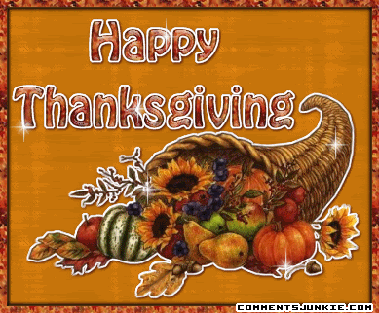
Thanksgiving
感恩節
In the U.S.A., the most famous holiday food is turkey. On Thanksgiving, almost everyone has it.
But do you know why turkey is the Thanksgiving food? In 1588, England won a very important battle. The queen wanted to celebrate, so she ate a goose. That was the first Thanksgiving. But nobody knows whether the story is true or not.
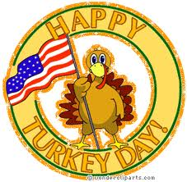
When British people moved to America, they wanted to keep the tradition going, but there were not enough geese. There were plenty of turkeys, so they ate those. They also had corn, deer, and other birds.
The U.S.A. has a special tradition. Every year, the president saves one turkey. He picks one lucky turkey and lets it live. Instead of being baked and becoming a Thanksgiving meal, the turkey becomes pets.
People love Thanksgiving. Families get together. The food is great. It’s also a chance to be thankful. But turkeys don’t like this holiday! After all, millions of them go from farms to kitchen tables.
Word Bank
turkey(n)火雞 | celebrate(v)慶祝
goose(n)鵝 | tradition(n)傳統
corn(n)玉米 | president(n)總統
bake(v)烤 | thankful(adj)感激的
after all畢竟 | millions of無數的

